1.(a)

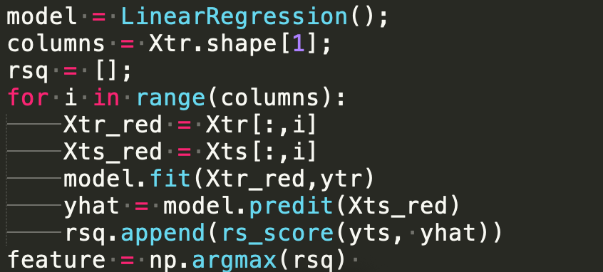

(b)

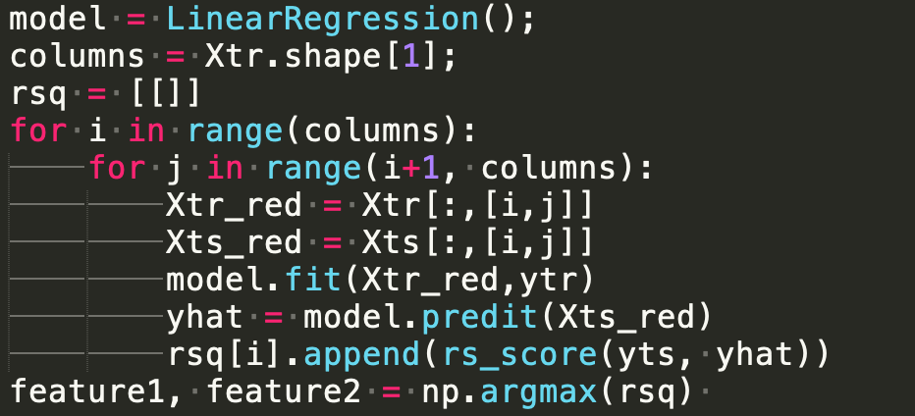

(c)

best k of p features: $C_{p}^{k}$

when k =10, p=1000 , it will need to call $C_{1000}^{10}$ times fit function.

2.

(a) $ϕ\left(ω\right)= \sum_{i=0}^{d}{|ω|}$

(b) $ϕ\left(ω\right)= \sum_{i=0}^{d}{-ω}$

(c) $ϕ\left(w\right)=\sum_{i=0}^{d}{{\left(ω_{i}-ω_{i+1}\right)}^{2}}$

(d) $ϕ\left(w\right)=\sum_{i=0}^{d}{{|ω_{i}-ω_{i+1}|}^{}}$

4.

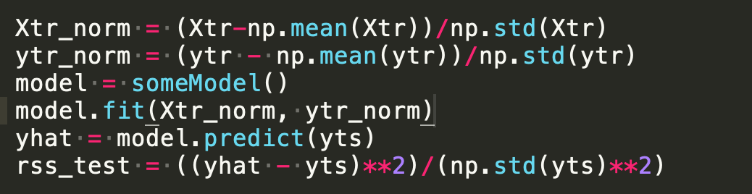

5.

